Muhammad Ali: Portrait of a Sales Champion

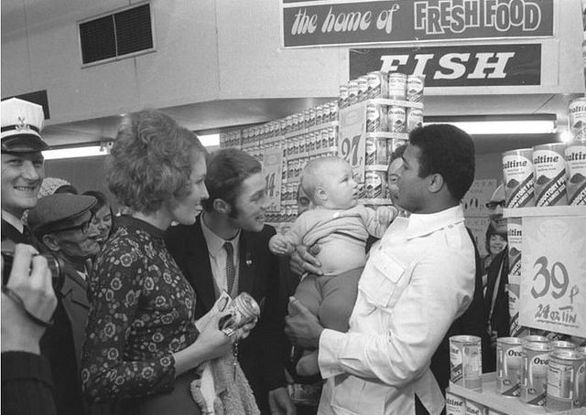

When you think of Muhammad Ali, what comes to mind? Is it Ali as we know him today, a quiet and frail man? Is it his incredible speed in the ring? Or is it his bravado?

After much research, I submit to you Ali may also be the Greatest Salesman of all Time.

When you think about it, we’re all constantly selling. If you’re a recruiter you’re selling your open positions. If you’re a manager you’re selling your employees on the importance of a job well done. Most of us never interact directly with customers, but we’re still selling all day long.

Let’s see what Muhammad Ali can teach us about becoming a world champion salesperson.

Confidence

A great salesperson has an abundance of confidence. It may even border on arrogance. Champion boxers and salespeople need a huge supply of both. Both know it’s just a numbers game until they get knocked out of the fight or deal.

Can you imagine how scary it must be to enter a boxing ring? Ali was scared – maybe terrified – when he first fought Sonny Liston. How did he overcome this? Through positive affirmations and self-talk. Consider the power of saying over and over, “Ain’t he ugly? He’s too ugly to be the world’s champ. The world’s champs should be pretty like me.” Before he fought Joe Frazier, Ali said, “My only fault is I don’t realize how great I really am.”

Now that’s what I call confidence. Of course, it is possible to be overconfident and arrogant, and I’m certainly not encouraging that. But when you’re an Olympic Gold Medalist, the first and only three-time World Champion, and the only person to come out of retirement and reclaim the World Championship, you’ve earned your bragging rights.

What technique do you use to overcome fear? Positive self-talk is one of the most accessible tools in your arsenal. It becomes even more powerful when you say it to other people. So stop being afraid. Instead, get out there and “float like a butterfly and sting like a bee.”

Preparation

A world class salesperson always thoroughly prepares for a meeting, and is ready for any objection that might be raised.

Ali knew the importance of training and preparation. He knew his health was critical to his success and understood the fundamentals of nutrition. Even before he converted to Islam he never drank or smoked. His workouts were legendary. When you watch this video, ask yourself: could you work out like this and still talk smack to reporters?

https://www.youtube.com/watch?v=1CO1Hx_DVSU

Preparation is mental and physical. How do you prepare to persuade or sell people? Do you take care of your body? Do you practice your presentation? Do you test your equipment before a demonstration? Don’t leave anything to chance. Preparation truly is the key to success.

Authenticity

My good friend Thomas Ellis is a world class sales trainer. We recently had a conversation about blog topics. I mentioned that a marketing expert didn’t think I should blog about famous people anymore, and that I was injecting too much fun into my writing. I explained to Ellis that I struggled with this advice because I wanted to continue to celebrate our living legends. I also can’t work unless I’m having fun. I think about Ellis’ advice every day: “You’ve got to be you, Liz. Don’t try to be anyone else.”

Isn’t this freeing?

In his heyday, it’s clear that Ali was completely comfortable in his own skin. He never tried to be anything other than himself. His authenticity comes shining through whether he’s clowning around with kids, signing autographs, or fighting. As he said, “I don’t have to be what you want me to be. I’m free to be who I wanna be and think what I wanna think.“ We wouldn’t want him any other way, and I doubt he’s changed. I doubt Ali’s lost the playfulness that he had when this episode of Candid Camera was filmed.

https://www.youtube.com/watch?v=-yNWfRfaHPU

Value

Every champion salesperson sells on value, not price. Discounting erodes profits and brands. A champion stands firm on price and solves customer’s problems.

Ali and Howard Cosell had a close relationship over the years. Toward the end of his career, Cosell wondered whether Ali would ever fight again, and who his potential opponent could be. Ali responded, “I am the Lord of the Ring. I know my value. I know who I am. They are nothing without Muhammad Ali.”

Ali earned record-setting purses. He knew the value of his brand and wasn’t afraid to leverage it.

Conviction

A sales champion won’t even consider selling a product unless she completely understands it and believes in it. Asking a champ to sell a product without this conviction is a losing proposition.

One of the things I admire the most about Ali is his conviction in his faith. He put everything on the line for it. Ali was adamantly opposed to serving in Vietnam.

Ali grew up in Louisville, Kentucky, and was subjected to racism and segregation. He realized that a disproportionate number of African Americans were being drafted, and he also didn’t want to be on display at exhibition fights. But he’s a gentle giant. Although he’s a professional fighter, that’s a far cry from being a professional soldier. He believes that Islam is a religion of peace. The thought of having to kill someone is truly abhorrent to Ali. As he said, “I ain’t got no quarrel with the Vietcong.”

The boxing commission stripped him of his World Champion title. The government fined him $10,000 and sentenced him to five years in jail. While his sentence was appealed he was denied a license to fight in the US and his passport was revoked. Ali paid a heavy price for his convictions: he lost three of his prime fighting years.

Every day we’re faced with millions of choices. We can act in a manner that aligns with our convictions, morals, and ethics, or we can take shortcuts. In my experience, there aren’t any shortcuts. Acting in alignment with your convictions is never the easy path, but it’s always the most rewarding.

Legacy

During the 1960s and 1970s, Muhammad Ali was the most famous person on the planet. Although he was the World Champion, he was famous because he kept selling his fans every day – inside and out of the ring. But that was a long time ago, so why does he remain so popular?

I suspect it’s because Ali hasn’t changed over the years. His convictions haven’t changed, and he’s still the same Ali he was 30 years ago. He’s also left a legacy of memorable moments of self-promotion.

During a 1972 interview, David Frost asked Ali about his legacy. Ali responded:

“I’d like them to say:

He took a few cups of love.
He took one tablespoon of patience.
One tablespoon, teaspoon of generosity.
One pint of kindness.
He took one quart of laughter.
One pinch of concern.
And then he mixed willingness with happiness.
He added lots of faith.
And he stirred it up well.
Then he spread it over a span of a lifetime.
And he served it to each and every deserving person he met.”

And that, my friends, is the secret sauce to becoming a master salesperson, along with a side of a life well lived.

